“Un” Resilience: Drawing Insights from societal collapse

# introduction

Despite the extensive literature on resilience, the field often relies on generalized descriptions (Kirmayer et al., 2011), making it challenging to operationalize and measure resilience (Copeland et al., 2020). This difficulty may arise from the inherent challenge of directly observing resilience. When a system efficiently absorbs specific shocks, its observable resilience may be obscured by its absorptive capacity. For instance, if someone contracts COVID-19 but remains asymptomatic, their resilience to the virus remains unobserved and unmeasured.

Resilience discourse, widely applied across domains (Luthar, 2015), includes societal resilience defined by communities’ rebound capacity from crises (Fleming & Ledogar, 2008), encompassing resistance, recovery, and creativity (Maguire & Hagan, 2007). Scholars delineate social resilience into coping, adaptive, and transformative capacities. (Keck & Sakdapolrak, 2013). Essential for navigating challenges like climate change and urban expansion, quality of life indicators are crucial for a society’s ability to navigate uncertainty and adapt to shocks (Broch, 2013). However, resilience assumptions include linearity, distinct “stages” of absorption and recover, and “direct” system properties, with consensus on resilience definitions. While the core idea of resilience remains—bouncing back from stress or shock (Fleming & Ledogar, 2008) –varied perspectives challenge the identification of new contributions, requiring reconciliation.

Amid debates on identifying new contributions, a shift toward studying collapse emerges as an alternative perspective to understand societal responses to shocks. The ability to observe “collapse” opens new doors to look at a diversity of shock types—including financial, ecological, natural disasters, human displacement, and other socio-ecological disasters—of varying degrees and intersecting with one another to measure the collapse of society (even low-levels of “collapse,” meaning certain subsystems but not others). Peterson posits, “Collapse is the shadow of resilience; consequently, studying collapse is indirectly the study of what makes a system resilient” (*Understanding Collapse, in Stockholm Resilience Centre - Research.*, 2018). In this project, we propose to study the collapse of a society, which is observable through criteria established by Cumming and Peterson (2017), as a way to infer the typology of shocks that lead to collapse (observable) or resilience (potentially unobservable). While it might also be difficult to observe societal “collapse,” we rely on a proxy for identifying candidate global events by using perceived societal crises through news coverage.

For decades, scholars have focused on studying socio-ecological collapse, emphasizing that “collapse” does not imply dark, apocalyptic events. Debates exist on “how much and what kind of change constitutes collapse,” but criteria have been developed to systematically observe it (Cumming & Peterson, 2017). Cumming and Peterson explain, “Collapse and resilience are two sides of the same coin; collapse occurs when resilience is lost, and resilient systems are less likely to collapse” (Cumming & Peterson, 2017). The four criteria to identify societal collapse are (1) socio-ecological systems losing service or identity, (2) rapid loss of system identity, (3) significant capital loss, and (4) enduring impacts (Cumming & Peterson, 2017).

Based on the above, we will systematically measure the public perception of societal collapse using existing data sources. Employ Natural Language Processing (NLP) and Machine Learning (ML) techniques to extract insights from news articles contextualized by data collected in surveys and interviews. This multifaceted approach aims to characterize the interconnections of shock-types. The data will help to explain perceptions of and propensity for societal collapse. We purposefully avoid studying the system’s specific configuration during the collapse, focusing instead on high-level failures (e.g., economic system broadly, food systems broadly—not each subsystem's configuration) caused by shocks/stressors. Considering specific factors wouldn’t significantly enhance the state of the art using novel methodologies toward understanding resilience.

# Bibliometric Analysis of Social Resilience

Resilience can be conceptualized as a process, an attribute, and an outcome at the individual, family, and community levels (Aburn et al., 2016; Laksmita et al., 2020; Pfefferbaum et al., 2015; Southwick et al., 2014). Community resilience is distinguished from personal resilience in that community members, buttressed by available physical and social conditions and structures, work together to respond to and recover from the community's hardships and adversities. Community resilience is grounded in the ability of community members to take meaningful, deliberate, and collective action (Pfefferbaum et al., 2015). Community resilience thus enhances disaster preparedness and recovery (Pfefferbaum et al., 2015; West et al., 2020). In total, 199,253 publications related to resilience were identified in Scopus. The publication period was between 1851 and 2024. A peak of publications was reached in 2023 (n = 29,691), and around half of the publications reached in 2024 (n = 10,455). Most are articles (n = 135,007), conference papers (n = 27,060), book chapters (n = 14,668), and reviews (n = 12,997). The other document types, such as books, editorials, notes, conference reviews, letters, erratum, short surveys, data papers, retracted reports, and others, are limited in numbers (all less than three thousand). Most of the subject areas are social sciences (n = 49,912), engineering (n = 39,562), environmental science (n = 38,823), medicine (n = 36,130), and computer science (n = 28,276).

The concept of social resilience is quite complex and requires a deep understanding of various domains. It is a multidimensional subject and is the focus of cross-disciplinary research. Despite its challenging nature, exploring social resilience can help us better understand how communities and societies can adapt and recover from different challenges and crises. A bibliometric analysis was conducted. This analysis helped us to identify influential research and emerging trends (Merigó & Yang, 2017). The data for this analysis were retrieved from Scopus on April 18, 2024. Scopus was chosen as a search engine because it extensively covers STM[1] journal articles and references, allowing forward and backward searches (Burnham, 2006). The term “social resilience” is identified in the title, the abstract, and/or the keywords of the publications. However, certain words such as "mental health," "pharmaceutical," and "aviation were excluded from the final query[2]. In total, 1,211[3] publications related to social resilience were identified. The timespan of publication was founded between 1993 and 2024. All types of publications were included in the search. Looking at the document types (see Table 1), the majority are articles (n = 834) and book chapters (n = 129). The other document types, such as conference papers, reviews, editorials, books, notes, letters, conference reviews, erratum, and short surveys, are limited in numbers (all less than a hundred).

Table 1. Frequency of document types

|  |  |
| --- | --- |
| Document Types |  |
| Article | 834 |
| Book chapter | 129 |
| Conference paper | 87 |
| Review | 77 |
| Editorial | 23 |
| Book | 22 |
| Note | 22 |
| Letter | 10 |
| Other | 7 |

The VOS (Visualization Of Similarities) mapping method was used to calculate and locate each topic in a two-dimensional map so that the distance between two items reflects the similarity or relatedness of the items as accurately as possible (Van Nunen et al., 2018). The VOS clustering method was applied to cluster topics into different groups, where each cluster is marked with a different color (Van Eck et al., 2010; Waltman et al., 2010). The interpretation is as follows: the circles' size and the label's font represent the number of occurrences, the colors represent clusters, and the distance between two circles reveals their relatedness and similarity (Khalil & Crawford, 2015; Rizzi et al., 2014). The x-axis and y-axis have no special meaning; the maps may be freely rotated and flipped (Khalil & Crawford, 2015).

The number of peer-reviewed publications is an important indicator for measuring the development trend of a scientific research discipline or subject. As displayed in Figure 1, the number of social resilience publications has increased since 1992. There was only one publication on social resilience in 1993. Until 2011, publications on the topic remained limited (less than fifteen publications each year). From 2012, an increasing number of publications could be observed every year, with the exception of 2016, where a small decline could be observed. A peak of publications is reached in 2023 (n = 219), and there is a decline in 2024 (n = 66). Looking at the cumulative number of publications in Figure 1, it can be stated that the importance of safety culture research has increased. It took approximately twenty-five years (from 1993 until 2018 inclusive) to reach 400 publications on the topic of social resilience. In the following five years (from 2012 until 2023 inclusive), this number increased to almost 1220 publications.

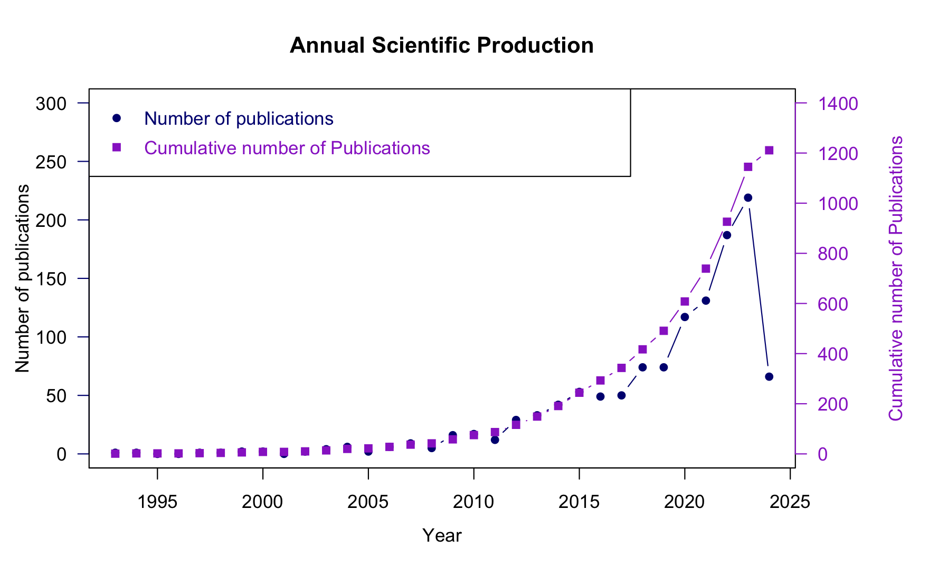

Figure 1. Annual Scientific Production for Social Resilience

A keyword co-occurrence analysis (co-word analysis) was conducted using the VOS mapping method to visualize the relationships of keywords or topics (Börner et al., 2003; Van Eck & Waltman, 2014). The result of the keyword co-occurrence analysis is presented in Figure 2. We select a threshold of six occurrences of a keyword as a minimum number of occurrences. This means that each of the 357 keywords[4] on the co-occurrence network in Figure 2 had appeared in at least six documents. There is no standard threshold for use in co-word analysis (Van Eck & Waltman, 2014). The co-word network map displays the frequency and relationships among 357 service-learning keywords/topics. The size of nodes on the map reflects the level of interest in a particular topic. Smaller nodes represent keywords that were mentioned at least six times in the document database. The positions, links, and proximity between nodes visualize the relatedness of topics studied in the literature. The lines or links between nodes indicate that the two keywords co-occurred, and the density of the lines suggests the frequency of co-occurrence. The proximity of nodes on the map suggests the degree to which nodes were related in the literature.

Figure 2. Network visualization of term co-occurrence of keywords

The keywords have been organized into four colored clusters, which suggest broad conceptual similarity among the keywords, as shown in Figure 2. In Cluster 1, which is indicated by the red color, researchers have observed that social resilience is interconnected with environmental problems, specifically climate change and the conservation of natural resources. This interconnectedness, in turn, is related to issues of food security, such as fishing and agriculture. Additionally, social resilience is linked to problems of migration, poverty, inequality, and social vulnerability. Studies that cover these issues mainly focus on ten countries: the United States, the United Kingdom, South Africa, India, Australia, Brazil, Germany, Mexico, Thailand, and Vietnam. In Cluster 2, identified by the green color, it has been observed that social resilience is closely linked to challenges faced by urban populations. Additionally, there is a significant correlation between social resilience and natural disasters such as floods, landslides, and earthquakes, specifically the risk and vulnerability levels of people to these events. Currently, social resilience is understood in the context of community resilience, economic resilience, and ecological resilience. Research on these issues has been mainly carried out in China, Africa, Indonesia, Iran, Japan, New Zealand, and Taiwan. In Cluster 3 (represented by the color blue), it is apparent that social resilience is linked to paying attention to the various obstacles that individuals encounter during their personal growth. These challenges may include issues related to childhood, youth, mental health (e.g., depression, anxiety), pregnancy, and sexuality. Furthermore, it is also associated with aspects such as health, education, and employment. Research on these issues has been mainly carried out in China. Cluster 4 (represented by the color yellow) shows a correlation between social resilience and its association with health, epidemics, and healthcare, particularly in the context of COVID-19. Additionally, there is research being conducted on individuals who are vulnerable to these health issues. Research on these issues has been mainly conducted in China and the United States.

Temporal co-word analysis has been utilized to visualize the progression of research topics based on the frequency of keyword occurrences at different time points. The network shown in Figure 3 can be interpreted by noting that the darker-colored nodes represent keywords or topics of recent interest, while the lighter-colored nodes are associated with topics that were popular earlier in the field's evolution. Additionally, larger nodes indicate the central topics in the field for a specific time period, while relatively smaller nodes represent peripheral topics. A threshold of six keyword occurrences was used to create this network. Since 2022, research on COVID-19 and human problems in cluster 3 has primarily focused on China.

Figure 3. Network visualization of term co-occurrence of keywords with time information

# Definition of concepts

The collapse has been defined from different social, economic, and social perspectives, specifically, as a rapid loss of an established social, political, and economic complexity (Tainter, 1988). Hanson and Rees (2008) defined collapse from a social perspective in which productivity is reduced, impacting social systems rapidly and causing significant disruptions that generate change. Abel et al. (2006) developed a comprehensive concept of collapse that incorporates different social and ecological perspectives and allows to address resilience and vulnerability, as in the case of socio-ecological collapse, understood as “(...) major losses of social, human, and natural capitals through the breakdown of social networks, deaths of individuals, loss of knowledge, depletion of flora and fauna for food and medicine, and loss of access to ceremonial sites and lands”.

The term "collapse" is not a standalone idea; it's intertwined with a complex web of related concepts found in literature. Within this network are terms like social-ecological systems, events, shocks, disasters, and crises, all of which are inherently linked to the notion of collapse. A system, as defined by (Ghosh, 2015), is an interconnected arrangement of elements organized to fulfill a purpose. In the context of human social-ecological systems, these elements encompass resources, nonhuman organisms, individuals, organizations, institutions, and technologies (Beddoe et al., 2009). Systems are generally influenced by events, defined assituations that occur within a certain timeframe and involve entities or objects (Rodrigues & Abel, 2019) and that can cause stress or shocks to a population.

Events can come in various types, each with its own set of associated characteristics. For instance, within a political context, the World Handbook of Political Indicators IV (WHIV)[5] provides a set of country-level measures for contentious political events and identifies particular components about them, such as an actor, an event form or type, and one or more targets, along with the date and location (Jenkins et al., 2012). WHIV contains 40 event forms but could be resumed into four main categories of event types such as protest, political violence, political sanctions, and political relaxations.

From the concept of the event systems theory, events acquire importance when they are novel, disruptive, and critical (reflecting an event's strength) (Morgeson et al., 2015). Complex systems, characterized by irregular and non-periodic dynamics, often give rise to extreme events with significant impact (Kantz, 2010). These events are the result of the interactions between internal functional subsystems, which operate at their own rhythms and can lead to the emergence of higher-order complex events (Ehresmann & Vanbremeersch, 2011) which in this proposal we understand as shock events.

A shock is characterized as an abrupt and substantial disturbance that tests a system's capacity to uphold its functionality and adjust to new situations(Srinivasan & Kumar, 2015). These disruptions encompass natural disasters, human-induced actions, and alterations in environmental conditions (Jenelius & Mattsson, 2020) and can be classified into different types based on their sources, including climate-related, economic, political, criminal, and health-related shocks (Clarke & Dercon, 2015).

Shock events such as disaster response, climate change or specific traumas, can have long-term effects on society, including changes in governance arrangements and resilience (Kaufmann, 2016), and by their very nature, often trigger ripple effects throughout society that extend far beyond their initial impact (Walrath et al., 2024). For instance, a natural disaster can not only cause immediate physical destruction but also disrupt supply chains, displace populations, and strain healthcare systems, leading to long-term social and economic consequences. Similarly, shock events like economic crises or political upheavals can erode trust in institutions, reshape power dynamics, and alter policy priorities, reshaping the socio-political landscape for years to come.

Authors like the Organization for Economic Co-operation and Development (OECD) (2014), and Pradhan and Mukherjee (2018) mention that at a macro level, shocks can be categorized into *covariate shock* and *idiosyncratic shock*. Covariate shock refers to events that affect entire nations or communities, encompassing natural disasters and economic fluctuations like price increases and economic downturns (Feeny & Miller-Dawkins, 2016). Idiosyncratic shock refers to events that specifically affect individuals and families, such as the death of the main breadwinner or the loss of income-generating activity (Feeny & Miller-Dawkins, 2016). When extrapolating this in terms of a system we should first define the system and its scope. For example, if we are talking about a global level Covariate shocks spread across borders, affecting multiple countries and regions simultaneously. Events such as the 2008 financial crisis or the COVID-19 pandemic are exemplifications of how shocks originating in one part of the world can rapidly cross borders in a covariate manner. However, if only one country is affected, it could be considered idiosyncratic. The same analogy can be applied if we define the system as a country, city, neighborhood or community.

Thus, by examining collapse as an observable phenomenon through specific criteria, and focusing on events that generate shock we try to infer the typology of shocks that lead to the collapse or not of a system and thus to resilience. Thus, this project is proposed as a bridge between theoretical debates on resilience and observations of social responses to shocks that precipitate collapse in order to understand not only the dynamics of social systems in the face of shock events, but also to analyze their elasticity in these situations.

# proposed Method

The research relies on using “inference from absence” or “negative inference” as an indirect/inverse way to measure the resilience of systems (Wallach, 2019). This approach has been used in various fields, including anthropology/paleontology, environmental sciences, and physics, where direct observation and/or measurement of a phenomenon is difficult or impossible. By focusing on societal collapse/crisis and characterizing interconnected shocks that led to collapse, we can provide insights about those societies experiencing shocks that did not collapse or fall into crisis.

The research methodology is divided into four phases. In Phase 1, we focus on identifying potential "candidate" shock events. In Phase 2, the emphasis shifts toward identifying those candidate shocks that can cause the system to collapse. Phase 3 involves analyzing the resilience of the collapsed systems and how they recovered. Finally, in Phase 4, the focus is on characterizing the attributes of the shocks that lead to collapse or crisis.

Our intention is to answer the following questions such as what shocks, including subsequent or co-occurring shocks, lead to social perceptions of crisis/disaster? How do we systematically identify societal collapse? What characterization of shock types and combinations leads to perceptions of societal collapse? How does the typology of shock types and combinations explain the propensity for societal collapse? What are the perceived mechanisms that fail?

## Phase 1: Identify cases of societal collapse/ “un” resilience

We will create a combined lexicon from several wordlists about ecological, humanitarian, political, and economic crises and then use it as a search query in newspaper articles outlets. Lexicon-based approaches are widely used to analyze financial (Schröter & Storjohann, 2015), political (Havumetsä, 2023; Zouave, 2014), and social (Jayanetti et al., 2023; Salem et al., 2022) crises. Furthermore, appropriately using lexicons for searching news is crucial because they extract valuable information from unstructured data sources (Shaikh et al., 2019), and more keywords can be added using different approaches to extract relevant keywords (Habibi & Popescu-Belis, 2015; Olteanu et al., 2014). Starting with CrisisLex, a lexicon of 380 automatically generated and human-curated terms frequently related to natural disasters and human-made disasters (Olteanu et al., 2014), we will expand the lexicon using data mining techniques to extract keywords from the handbooks used to codify political events and financial crises. Specifically, the World Handbook of Political Indicators IV (WHIV)[6] (Jenkins et al., 2012) for political events and The Handbook of the Political Economy of Financial Crises (Wolfson & Epstein, 2013) for financial crises.

Using the combined lexicon as a search query, we will extract the content and metadata from relevant newspaper articles across various news outlets. Metadata is structured information (variables) of a digital object, and it is as essential as the content itself (Khan et al., 2023). Therefore, for each new article, we will extract the title, content, date, language, country, and any other variables the data source can provide (sentiment, entities, URLs, etc). For the data extraction, we have already identified three potential data sources: LexisNexis News API[7], Quantexa News API[8], and NewsApi.ai[9].

*LexisNexis* is an online information retrieval system that provides access to various sources, including legal information, newspapers, magazines, company reports, and government documents (Scales, 1995). With over 70,000 web news sources at its disposal and an extensive archive spanning more than 45 years, LexisNexis facilitates the retrieval of titles, contents, and various other aspects of metadata. However, this platform does not allow downloading news content, which limits us from applying advanced ML and NLP models outside their environments, so we do not consider it fully feasible for this project.

On the other hand, *Quantexa* is an AI-powered news API that provides access to more than 90,000 trusted global content sources in multiple languages. Its premium plan offers to start at $49 and allows access to 30,000 items with the ability to extract and export the title and content of the news, among other aspects of metadata. The main limitation we encounter with Quantexa for our project is that its historical archive only spans the last 6 years. To assess its capabilities, we have purchased its most basic plan for $49 and have reached out to the sales team to inquire about price, the possibility of accessing an older archive, and downloading all news locally (the demo version only allowed downloading up to 1000 news articles). However, we have not yet received a response from the sales team. We consider this API a potentially viable option if we get an answer.

Our final option is NewsApi. This API offers access to global news sources in over 60 languages, with advanced filtering options for keywords, individuals, locations, sentiments, and more. It also provides access to titles, content, and various other aspects of metadata. Payment plans range from $90 to $3000. The latter plan allows the extraction of up to 10,000,000 news items in a historical archive up to 2014. The website specifies that if the extraction of more news are required, the sales team can be contacted to discuss a higher plan. The main and only limitation we have noticed up to this point with this API is its limited historical access up to 10 years ago. Otherwise, we can say that we consider it our main and best option.

After the process of news extraction, we will employ NLP and ML algorithms to identify "candidate “events” related to societal collapse in global news databases. These identified candidate events will be stored and named as a "Global Candidate Shock Events Database" (GCSED) and will serve as a centralized source of information on events to be analyzed in phase 2. Also, human coders will be used to verify that the NLP and ML algorithms correctly identify events.

To assess the likelihood of an event constituting a shock, this study adopts an analytical approach involving the identification of various quantifiable indicators typically mentioned in newspaper articles. Examples of such indicators include the count of human fatalities, the count of human refugees, and economic loss. Subsequently, these indicators undergo normalization relative to their respective maximum attainable values and are aggregated to derive a composite shock probability. These computed probabilities serve as the a priori values within a Bayesian network, wherein adjustments occur post-execution of the model, yielding updated (posterior) probabilities.

Figure 5a shows how different events are represented within their impact on the system and the time when they happened. In our analysis, events are defined as actions that exert visible effects on the system under consideration. These actions typically involve one actor exerting influence upon another, although instances exist where actions occur independently of any identifiable actor. Given the potential for events to initiate or influence subsequent events, causal relationships may exist among them. While multiple events may fall within the same category, each event exerts a unique impact on the system, depending on its societal variations and values (see Figure 5b). This discrepancy in impact serves as a distinguishing factor between systems. For instance, a 1% increase in inflation within Venezuela may not yield comparable impact to that of the United States, underscoring the significance of contextual differences in assessing systemic effects. Additionally, the co-occurrence of multiple systemic shocks has the potential to impact several subsystems and impact the system differently depending on its variations and values.

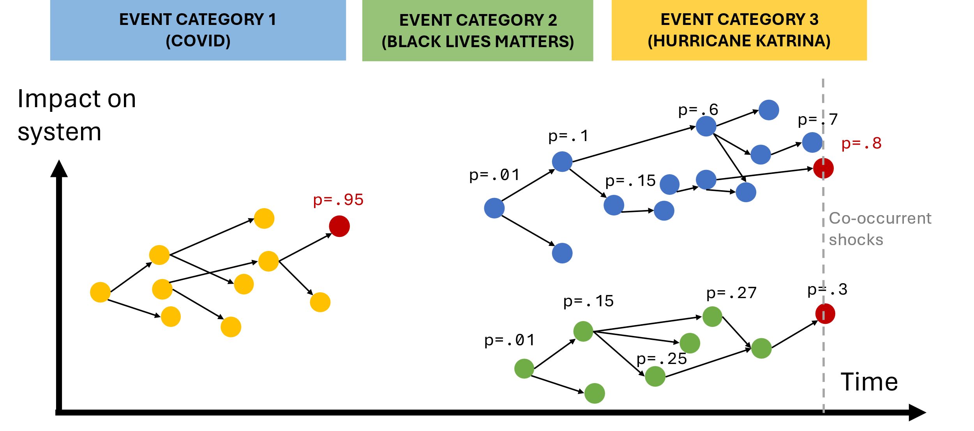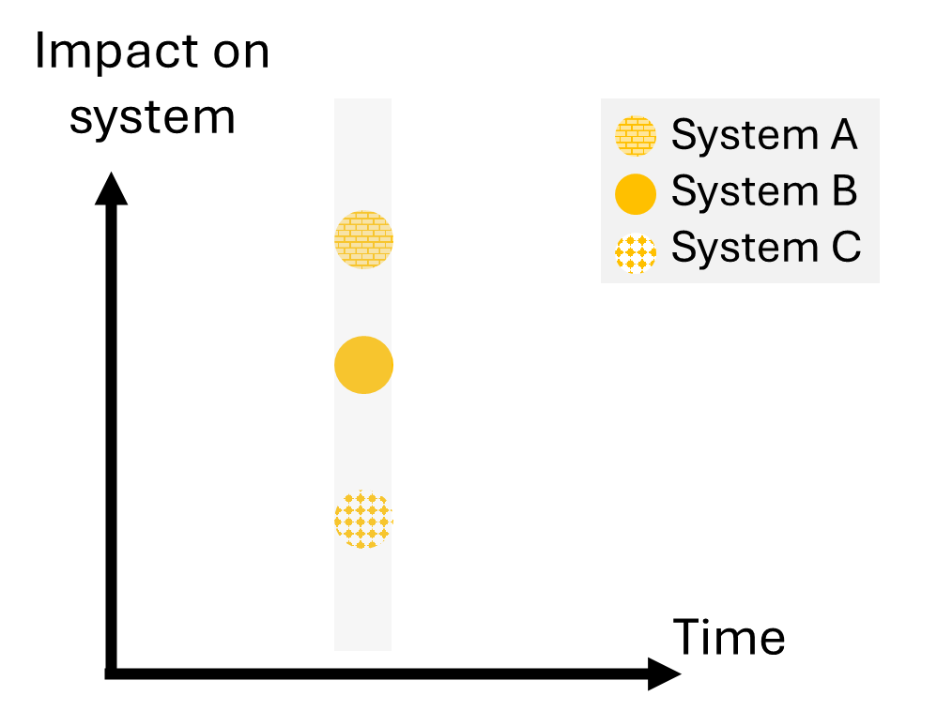

Figure 5. (a) Representation of events in terms of impact on a system and time, (b) Representation of the impact of the same event among different systems.

Human coders will be used to verify that the model correctly identifies shocks. In this dataset, we will also track aspects of the shocks, including the length of time the shock remained in public conversations, volume/number of national or international news outlets covering the shock, tone, and sentiment of coverage, and mentions of actors, institutions, systems, or services that ceased functioning.

REFERENCES

Abel, N., Cumming, D. H. M., & Anderies, J. M. (2006). Collapse and Reorganization in Social-Ecological Systems

Questions, Some Ideas, and Policy Implications. *Ecology and Society*, *11*(1).

Aburn, G., Gott, M., & Hoare, K. (2016). What is resilience? An integrative review of the empirical literature. *Journal of advanced nursing*, *72*(5), 980-1000.

<https://doi.org/10.1073/pnas.0812570106>

Broch, H. B. (2013). Social resilience-local responses to changes in social and natural environments. *Maritime Studies*, *12*(1), 6.

Burnham, J. F. (2006). Scopus database: a review. *Biomedical digital libraries*, *3*, 1-8.

Clarke, D., & Dercon, S. (2015). Insurance, credit and safety nets for the poor in a world of risk. *Financing for Overcoming Economic Insecurity*, 85-110.

Copeland, S., Comes, T., Bach, S., Nagenborg, M., Schulte, Y., & Doorn, N. (2020). Measuring social resilience: Trade-offs, challenges and opportunities for indicator models in transforming societies. *International journal of disaster risk reduction*, *51*, 101799.

Cumming, G. S., & Peterson, G. D. (2017). Unifying research on social–ecological resilience and collapse. *Trends in ecology & evolution*, *32*(9), 695-713.

Ehresmann, A. C., & Vanbremeersch, J.-P. (2011, 2011//). Analysis of Complex Events in Memory Evolutive Systems. Towards a Service-Based Internet. ServiceWave 2010 Workshops, Berlin, Heidelberg.

Feeny, S., & Miller-Dawkins, M. (2016). Household Vulnerability and Resilience to Economic Shocks in Melanesia: An Overview. *Household Vulnerability and Resilience to Economic Shocks*, 1-22.

Fleming, J., & Ledogar, R. J. (2008). Resilience, an evolving concept: A review of literature relevant to Aboriginal research. *Pimatisiwin*, *6*(2), 7.

Ghosh, A. (2015). Thinking in Systems. In (pp. 1-17). Springer International Publishing. <https://doi.org/10.1007/978-3-319-10735-6_1>

Habibi, M., & Popescu-Belis, A. (2015). Keyword extraction and clustering for document recommendation in conversations. *IEEE/ACM Transactions on audio, speech, and language processing*, *23*(4), 746-759.

Hanson, R., & Rees, M. J. (2008). Catastrophe, social collapse, and human extinction. In N. Bostrom & M. M. Cirkovic (Eds.), *Global Catastrophic Risks* (pp. 0). Oxford University Press. <https://doi.org/10.1093/oso/9780198570509.003.0023>

Havumetsä, N. (2023). Lexical borrowing in journalism in a time of political crisis. *Perspectives*, *31*(3), 562-575.

Jayanetti, H. R., Frydenlund, E., & Weigle, M. C. (2023). Xenophobic Events vs. Refugee Population--Using GDELT to Identify Countries with Disproportionate Coverage. *arXiv preprint arXiv:2308.05038*.

Jenelius, E., & Mattsson, L.-G. (2020). Resilience of Transport Systems. In.

Jenkins, C. J., Taylor, C. L., Abbott, M., Maher, T. V., & Peterson, L. (2012). The World Handbook of political indicators IV: An introduction and codebook. *Mershon Center for International Security Studies, The Ohio State University*.

Kantz, H. (2010). Dynamics and Statistics of Extreme Events. In (pp. 205-216). Springer London. <https://doi.org/10.1007/978-1-84996-396-1_10>

Keck, M., & Sakdapolrak, P. (2013). What is social resilience? Lessons learned and ways forward. *Erdkunde*, 5-19.

Khalil, G. M., & Crawford, C. A. G. (2015). A bibliometric analysis of US-based research on the behavioral risk factor surveillance system. *American journal of preventive medicine*, *48*(1), 50-57.

Khan, M., Alharbi, Y., Alferaidi, A., Alharbi, T. S., & Yadav, K. (2023). Metadata for Efficient Management of Digital News Articles in Multilingual News Archives. *SAGE Open*, *13*(4), 21582440231201368.

Kirmayer, L. J., Dandeneau, S., Marshall, E., Phillips, M. K., & Williamson, K. J. (2011). Rethinking resilience from indigenous perspectives. *The Canadian Journal of Psychiatry*, *56*(2), 84-91.

Laksmita, O. D., Chung, M. H., Liao, Y. M., Haase, J. E., & Chang, P. C. (2020). Predictors of resilience among adolescent disaster survivors: A path analysis. *Journal of Advanced Nursing*, *76*(8), 2060-2071.

Luthar, S. S. (2015). Resilience in development: A synthesis of research across five decades. *Developmental psychopathology: Volume three: Risk, disorder, and adaptation*, 739-795.

Maguire, B., & Hagan, P. (2007). Disasters and communities: Understanding social resilience. *Australian Journal of Emergency Management, The*, *22*(2), 16-20.

Merigó, J. M., & Yang, J.-B. (2017). A bibliometric analysis of operations research and management science. *Omega*, *73*, 37-48.

OECD. (2014). *Guidelines for Resilience Systems Analysis: How to Analyse Risk and Build a Roadmap to Resilience*. <https://doi.org/doi:https://doi.org/10.1787/3b1d3efe-en>

Olteanu, A., Castillo, C., Diaz, F., & Vieweg, S. (2014). CrisisLex: A Lexicon for Collecting and Filtering Microblogged Communications in Crises. *Proceedings of the International AAAI Conference on Web and Social Media*, *8*(1), 376-385. <https://doi.org/10.1609/icwsm.v8i1.14538>

Pfefferbaum, R. L., Pfefferbaum, B., Nitiéma, P., Houston, J. B., & Van Horn, R. L. (2015). Assessing community resilience: An application of the expanded CART survey instrument with affiliated volunteer responders. *American Behavioral Scientist*, *59*(2), 181-199.

Pradhan, K. C., & Mukherjee, S. (2018). Covariate and Idiosyncratic Shocks and Coping Strategies for Poor and Non-poor Rural Households in India. *Journal of Quantitative Economics*, *16*(1), 101-127. <https://doi.org/10.1007/s40953-017-0073-8>

Rizzi, F., van Eck, N. J., & Frey, M. (2014). The production of scientific knowledge on renewable energies: Worldwide trends, dynamics and challenges and implications for management. *Renewable Energy*, *62*, 657-671.

Rodrigues, F. H., & Abel, M. (2019). What to consider about events: A survey on the ontology of occurrents. *Applied ontology*, *14*(4), 343-378.

Salem, S., Mansour, N. M., Hassan, I. H., & Debian, R. A. (2022). Investigating the Role of Conceptual Metaphor in the Representation of the Syrian Human Crisis in British Newspaper Articles: A Cognitive Approach. *Journal of Language and Literature*, *22*(1), 1-14.

Schröter, M., & Storjohann, P. (2015). Patterns of discourse semantics: A corpus-assisted study of financial crisis in British newspaper discourse in 2009. *Pragmatics and Society*, *6*(1), 43-66.

Shaikh, A., Mahoto, N. A., & Unar, M. A. (2019). A Lexicon based Approach Towards Concept Extraction. *3c Tecnología: glosas de innovación aplicadas a la pyme*, *8*(1), 50-67.

Southwick, S. M., Bonanno, G. A., Masten, A. S., Panter-Brick, C., & Yehuda, R. (2014). Resilience definitions, theory, and challenges: interdisciplinary perspectives. *European journal of psychotraumatology*, *5*(1), 25338.

Srinivasan, V., & Kumar, P. (2015). Emergent and divergent resilience behavior in catastrophic shift systems. *Ecological Modelling*, *298*(C), 87-105. <https://doi.org/10.1016/j.ecolmodel.2013>. (Ecological Modelling)

Tainter, J. (1988). *The collapse of complex societies*. Cambridge university press.

*Understanding Collapse, in Stockholm Resilience Centre - Research.* (2018).

Van Eck, N. J., & Waltman, L. (2014). Visualizing bibliometric networks. In *Measuring scholarly impact: Methods and practice* (pp. 285-320). Springer.

Van Eck, N. J., Waltman, L., Dekker, R., & Van Den Berg, J. (2010). A comparison of two techniques for bibliometric mapping: Multidimensional scaling and VOS. *Journal of the American Society for Information Science and Technology*, *61*(12), 2405-2416.

Van Nunen, K., Li, J., Reniers, G., & Ponnet, K. (2018). Bibliometric analysis of safety culture research. *Safety science*, *108*, 248-258.

Wallach, E. (2019). Inference from absence: the case of archaeology. *Palgrave Communications*, *5*(1), 1-10.

Waltman, L., Van Eck, N. J., & Noyons, E. C. (2010). A unified approach to mapping and clustering of bibliometric networks. *Journal of informetrics*, *4*(4), 629-635.

West, C. P., Dyrbye, L. N., Sinsky, C., Trockel, M., Tutty, M., Nedelec, L., Shanafelt, T. D. (2020). Resilience and burnout among physicians and the general US working population. *JAMA network open*, *3*(7), e209385-e209385.

Wolfson, M. H., & Epstein, G. A. (2013). *The handbook of the political economy of financial crises*. OUP USA.

Zouave, S. (2014). Manipulation in Newspaper Articles: A Political Discourse Analysis of Lexical Choice and Manipulation in Japanese Newspaper Crisis Reporting in the case of North Korea. In.

1. <https://www.stmjournals.com/>
2. “social resilience” AND NOT ("mental health" OR pharmaceutical OR aviation)
3. In total, 1,294 publications were published, but after excluding certain words such as “mental health”, “pharmaceutical”, and “aviation”, we obtained 1,211 results identified in Scopus.
4. There was a total of 7,243 keywords.
5. <https://sociology.osu.edu/worldhandbook>
6. <https://sociology.osu.edu/worldhandbook>
7. <https://www.lexisnexis.com/en-gb/products/nexis-daas/news-api>
8. <https://aylien.com/product/news-api>
9. <https://www.newsapi.ai/>